**Module 8 - Microservices with Spring Boot 3 and Spring Cloud**

**2. Microservices with API gateway**

**Creating Microservices for account and loan**

**Structure:**

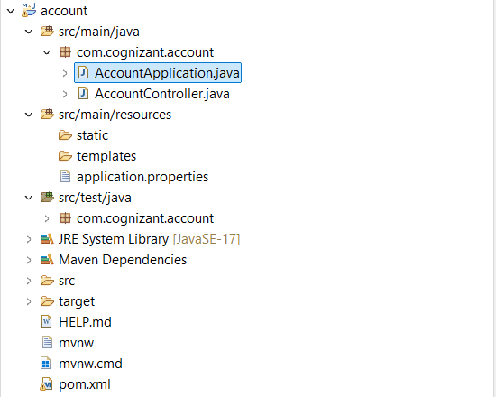

**AccountApplication.java:**

package com.cognizant.account;

import org.springframework.boot.SpringApplication;

import org.springframework.boot.autoconfigure.SpringBootApplication;

@SpringBootApplication

public class AccountApplication {

public static void main(String[] args) {

SpringApplication.*run*(AccountApplication.class, args);

}

}

**AccountController.java:**

package com.cognizant.account;

import org.springframework.web.bind.annotation.*;

@RestController

public class AccountController {

@GetMapping("/accounts/{number}")

public Account getAccountDetails(@PathVariable String number) {

return new Account(number, "savings", 234343);

}

// Inner class to simulate account data

class Account {

private String number;

private String type;

private double balance;

public Account(String number, String type, double balance) {

this.number = number;

this.type = type;

this.balance = balance;

}

public String getNumber() { return number; }

public String getType() { return type; }

public double getBalance() { return balance; }

}

}

**application.properties:**

server.port=8080

**pom.xml:**

<?xml version="1.0" encoding="UTF-8"?>

<project xmlns="http://maven.apache.org/POM/4.0.0"

xmlns:xsi="http://www.w3.org/2001/XMLSchema-instance"

xsi:schemaLocation="http://maven.apache.org/POM/4.0.0

http://maven.apache.org/xsd/maven-4.0.0.xsd">

<modelVersion>4.0.0</modelVersion>

<parent>

<groupId>org.springframework.boot</groupId>

<artifactId>spring-boot-starter-parent</artifactId>

<version>3.5.3</version>

<relativePath/> <!-- lookup parent from repository -->

</parent>

<groupId>com.cognizant</groupId>

<artifactId>account</artifactId>

<version>0.0.1-SNAPSHOT</version>

<name>account</name>

<description>Demo project for Spring Boot</description>

<packaging>jar</packaging>

<properties>

<java.version>17</java.version>

</properties>

<dependencies>

<!-- Spring Web -->

<dependency>

<groupId>org.springframework.boot</groupId>

<artifactId>spring-boot-starter-web</artifactId>

</dependency>

<!-- DevTools for hot reload -->

<dependency>

<groupId>org.springframework.boot</groupId>

<artifactId>spring-boot-devtools</artifactId>

<scope>runtime</scope>

<optional>true</optional>

</dependency>

<!-- For unit testing (optional, default included) -->

<dependency>

<groupId>org.springframework.boot</groupId>

<artifactId>spring-boot-starter-test</artifactId>

<scope>test</scope>

</dependency>

</dependencies>

<build>

<plugins>

<!-- Spring Boot Maven Plugin -->

<plugin>

<groupId>org.springframework.boot</groupId>

<artifactId>spring-boot-maven-plugin</artifactId>

<version>3.5.3</version>

</plugin>

</plugins>

</build>

</project>

**Output:**

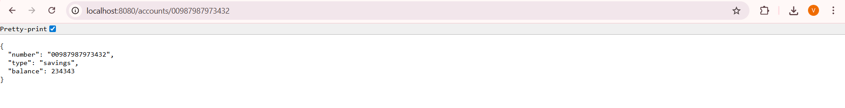

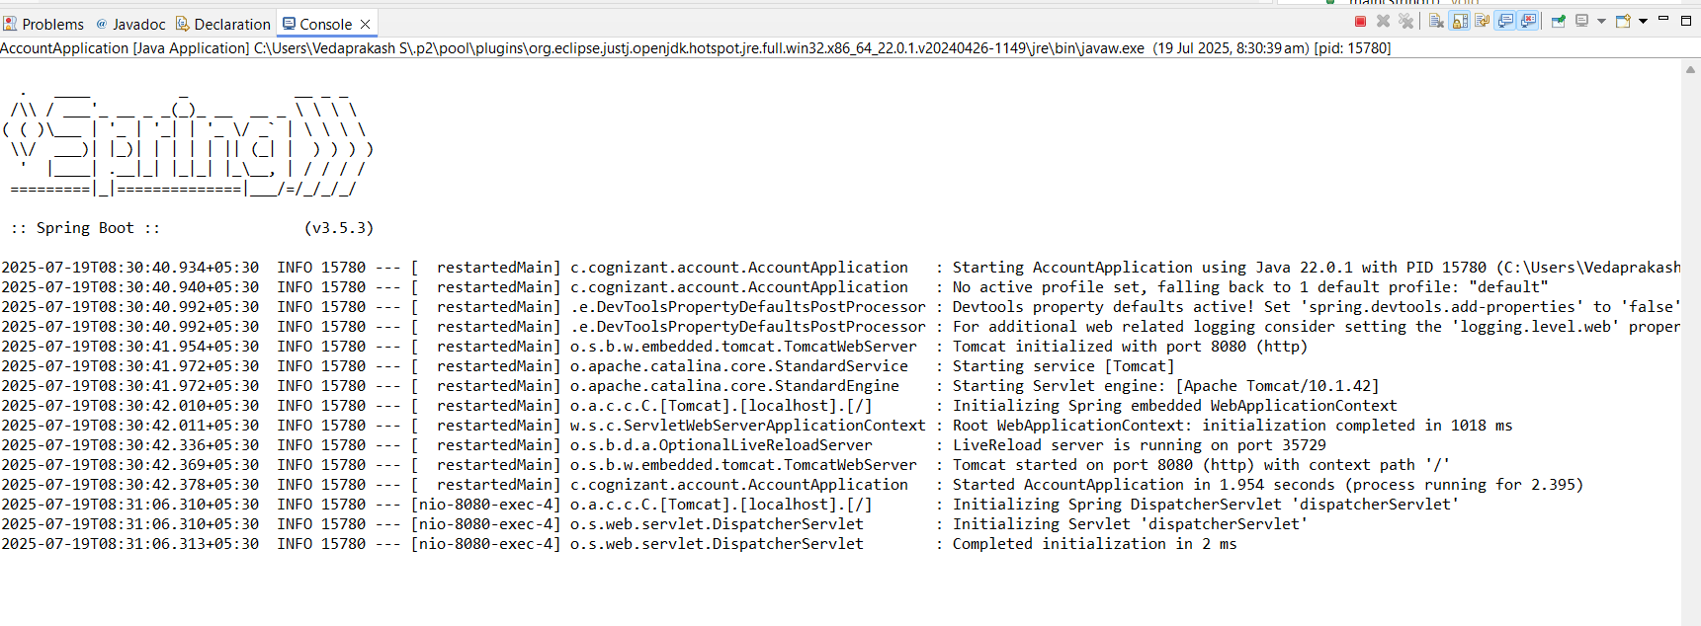

**Structure:**

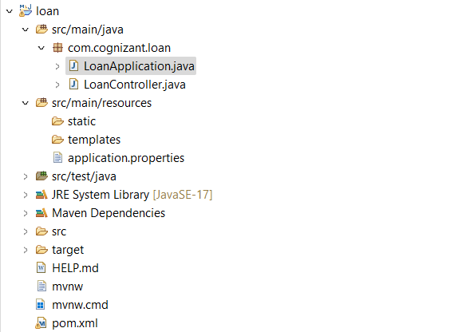

**LoanApplication.java:**

package com.cognizant.loan;

import org.springframework.boot.SpringApplication;

import org.springframework.boot.autoconfigure.SpringBootApplication;

@SpringBootApplication

public class LoanApplication {

public static void main(String[] args) {

SpringApplication.*run*(LoanApplication.class, args);

}

}

**LoanController.java:**

package com.cognizant.loan;

import org.springframework.web.bind.annotation.*;

@RestController

public class LoanController {

@GetMapping("/loans/{number}")

public Loan getLoanDetails(@PathVariable String number) {

return new Loan(number, "car", 400000, 3258, 18);

}

class Loan {

private String number;

private String type;

private double loan;

private int emi;

private int tenure;

public Loan(String number, String type, double loan, int emi, int tenure) {

this.number = number;

this.type = type;

this.loan = loan;

this.emi = emi;

this.tenure = tenure;

}

public String getNumber() { return number; }

public String getType() { return type; }

public double getLoan() { return loan; }

public int getEmi() { return emi; }

public int getTenure() { return tenure; }

}

}

**application.properties:**

server.port=8081

**pom.xml:**

<?xml version="1.0" encoding="UTF-8"?>

<project xmlns="http://maven.apache.org/POM/4.0.0"

xmlns:xsi="http://www.w3.org/2001/XMLSchema-instance"

xsi:schemaLocation="http://maven.apache.org/POM/4.0.0

http://maven.apache.org/xsd/maven-4.0.0.xsd">

<modelVersion>4.0.0</modelVersion>

<parent>

<groupId>org.springframework.boot</groupId>

<artifactId>spring-boot-starter-parent</artifactId>

<version>3.5.3</version>

<relativePath/>

</parent>

<groupId>com.cognizant</groupId>

<artifactId>loan</artifactId>

<version>0.0.1-SNAPSHOT</version>

<name>loan</name>

<description>Loan Microservice</description>

<packaging>jar</packaging>

<properties>

<java.version>17</java.version>

</properties>

<dependencies>

<!-- Spring Web -->

<dependency>

<groupId>org.springframework.boot</groupId>

<artifactId>spring-boot-starter-web</artifactId>

</dependency>

<!-- DevTools for hot reload -->

<dependency>

<groupId>org.springframework.boot</groupId>

<artifactId>spring-boot-devtools</artifactId>

<scope>runtime</scope>

<optional>true</optional>

</dependency>

<!-- Testing (optional) -->

<dependency>

<groupId>org.springframework.boot</groupId>

<artifactId>spring-boot-starter-test</artifactId>

<scope>test</scope>

</dependency>

</dependencies>

<build>

<plugins>

<plugin>

<groupId>org.springframework.boot</groupId>

<artifactId>spring-boot-maven-plugin</artifactId>

<version>3.5.3</version>

</plugin>

</plugins>

</build>

</project>

**Output:**

